NORTH SOUTH UNIVERSITY



Department of Electrical & Computer Engineering (ECE)

| Group Members Name: | Rowda Ridwana (ID: 2014275042)  Jonak Bhowmik (ID: 2211148642)  Md. Mahdi Hasan Tazelly (ID: 2212193042)  Marufa Akter Maria (ID: 2222966642) |
| --- | --- |
| **Project Name:** | **ICC Men's ODI World Cup 2023 Players Database** |
| **Group No:** | **02** |
| **Course Code:** | **CSE-225** |
| **Section** | **12** |
| **Faculty Initial:** | **MRH1** |
| **Date of Submission** | **04/11/2023** |

***For Instructor's use only***

| SCORE: | REMARKS: |
| --- | --- |
| PENALTY: |

| **Table of Content**  1. The List of Functions Contributed by Each of Our Group Members  2. Features  3. Descriptions of the functions used in this Project  4. Applications and Use of The Project:  5. Limitations  6. Future work  7. Source of the stats or information  8. Backup link of this project |
| --- |

**The List of Functions Contributed by Each of Our Group Members:**

**Md. Mahdi Hasan Tazelly:**

* insert()
* search()

**Marufa Akter Maria :**

* menu()
* del()

**Jonak Bhowmik:**

* update()

**Rowda Ridwana:** display()

**Features:**

1. It works as a database.
2. Can save the information in a text file.
3. Can add new player's information.
4. Can update their information or stats.
5. Can search the information.
6. Can display the file in the console.
7. Can delete any player’s information.

**Descriptions of the functions used in this Project:**

Our program consists of 1 player class and 4 functions.Which are

1. insert()

2. search()

3. del()

4. update()

5. display()

The functions and menu options are described below:

**1. Menu:**

The menu function displays a menu to interact with a player database. It provides options like add, search, update, delete a player, and exit the program for users.

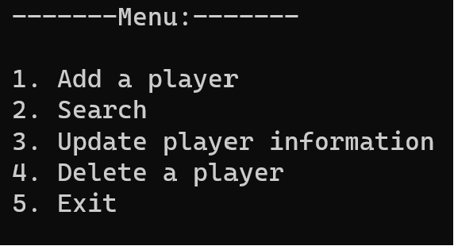

* To input details of a new player press 1.
* To search information of any player from any team press 2 .
* To update a player's information that has been added before press 3 .
* To delete a specific player’s information from the database press 4.
* Finally, to exit the program press 5. This option gives a “good bye” message and terminates the program.

**2. Insert():**

From the menu, entering number 1 in the console can lead you to the insert page, where you can insert a player’s name and any other details(name, world cup attended, playing role, total matches, total runs, total wickets). In the case of a batter, you need to enter NA in response to wickets.

After choosing the insert option, you will encounter another pop-up message to choose the country where you want to enter player information.

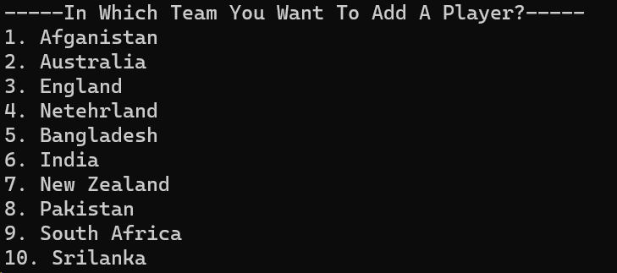

Then you can normally choose any country. If you want to enter a player's info in the English squad, choose 3. You will be asked to enter the player's name.

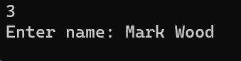

After that, how many World cup he played.

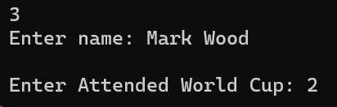

Then total played matches, total runs, and total wickets he bagged accordingly.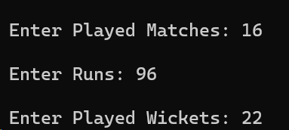

Bingo! Now the player’s information has been saved into the text file of the English squad.

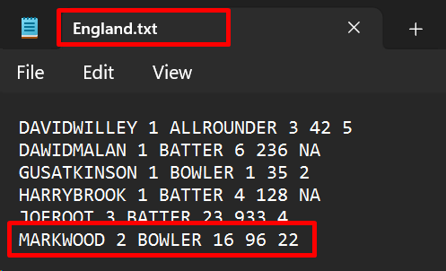

**N.B:** If you enter the name, and playing role as a mixture of uppercase, lowercase letters, and space, the program will trim the spaces and turns the lowercase letter into uppercase.

**In text file: In the Input Console:**

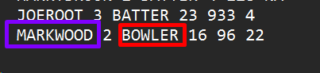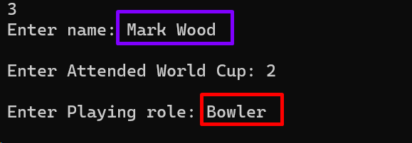

**3. Search():**

From the main menu, if you choose to search, you will encounter another sub-menu for searching the information on the players.

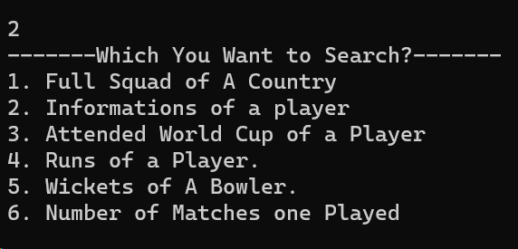

As we entered a player’s info in the England team, let’s explore the search based on the England.

* If you enter 1, the program will show you the full squad of any particular team.

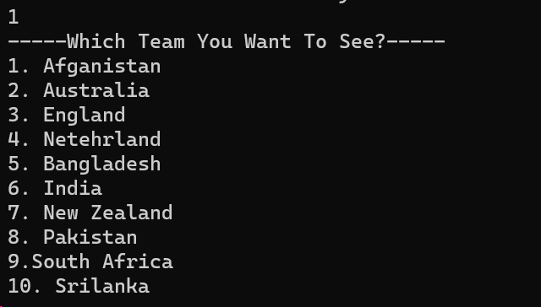

If you enter 3, the program will show you all the players’ information((name, world cup attended, playing role, total matches, total runs, total wickets) of the English squad. Here it is!

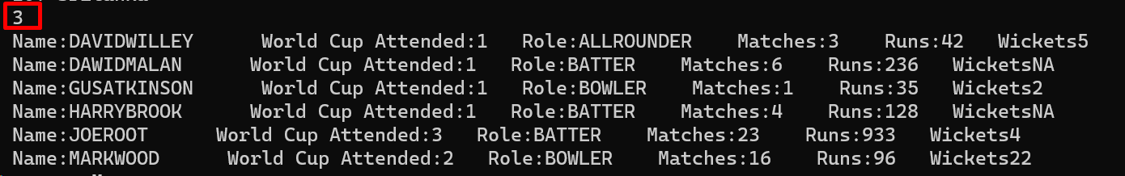

* By choosing 2, you can search any one player’s information

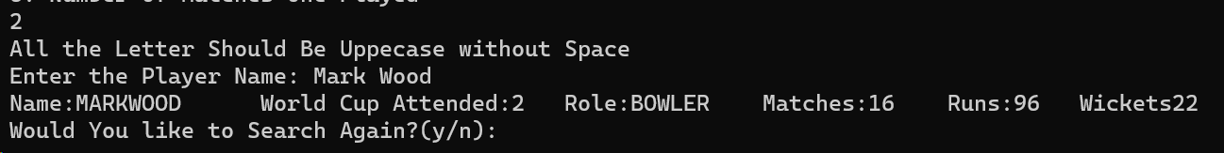

If you enter y(Lower case), you can search for another player’s info.

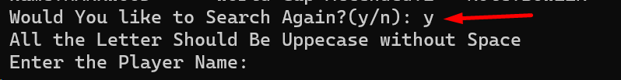

If n, it will lead you to the menu page.

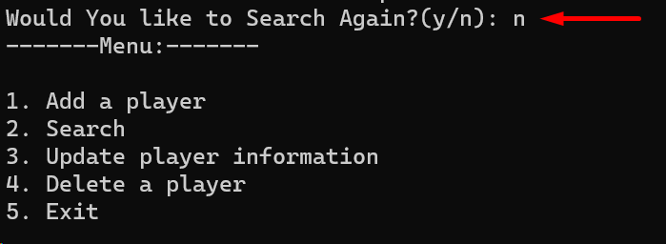

* Entering 3 you can check the played world cups of a particular player.

**In Console: In the Text File:**

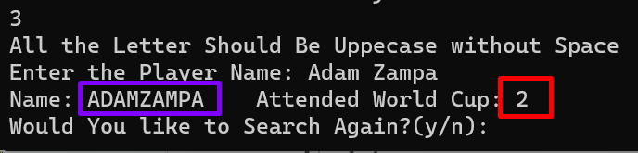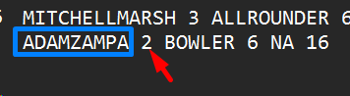

* If you want to see the total runs of a player, you should enter 4. And then simply write the name of the player.

**In Console: In the Text File:**

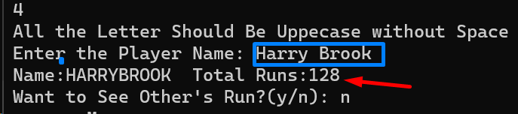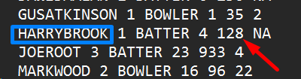

* For watching how many wickets a particular bowler has bagged, enter 5.

**In Console: In the Text File:**

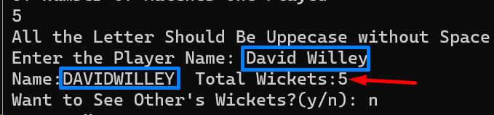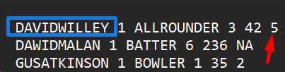

* Choose 6 to see the number of total matches one particular player has played and enter the player’s name.

**In Console: In the Text File:**

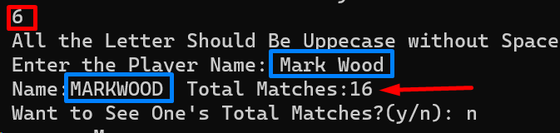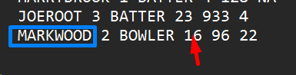

**4. Del():**

The del() function handles the deletion of a specific player’s information from the player database.Users can select the team from which they want to remove a player and provide the player’s name to delete.The function updates the database accordingly. From the menu, if the user enters “ 4” he will get options of 10 different countries that took part in the World Cup 2023.

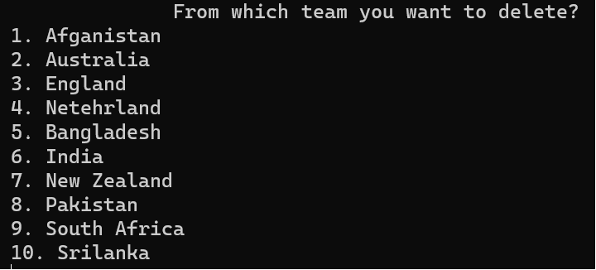

After choosing one of these countries, the user is prompted to enter the name of the player whose information he wants to delete.

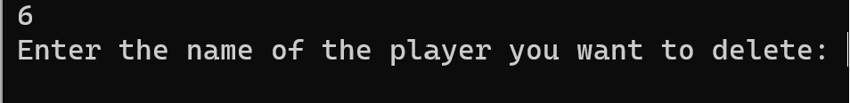

After the user enters the player name ,The function determines the filename associated with the selected team using a series of conditional statements.Then, a temporary file named “temp.txt” has been created to hold the modified data during the deletion process. The selected function starts reading the selected team’s player data file line by line.When the name matches with the entered name we can see full information of that player in the output and eventually it gets removed from the file.

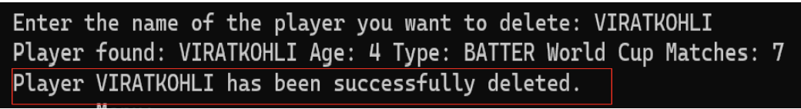

* Here, we can see the screenshots of the console and the file before deletion and after deletion .

**Before deletion(Console):**

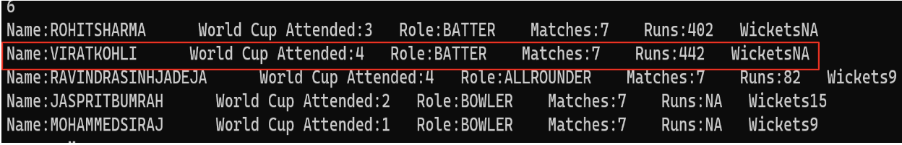

**After deletion(Console):**



**Before deletion(file): After deletion(file):**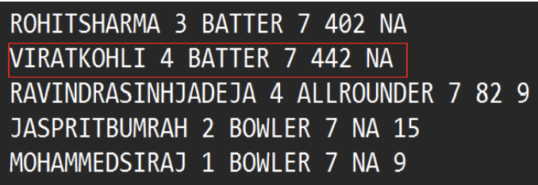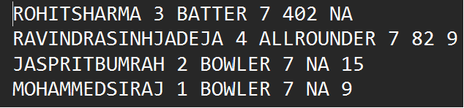

* If the name entered does not match with any of the names that were saved in the file ,a message “Could not find this name” will appear on the screen . As the user deleted the information of VIRAT KOHLI, he will get a not found message if wants to delete the same name again.

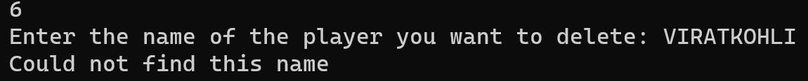

**5. Update():**

**Purpose of the update function**  
  
As the name suggests, this function is dedicated to updating or changing the player information. In this database, there is some information about a player like his name, his role in the team, how many World Cups he has played for his country, the number of matches played in the ODI World Cup and how many runs or wickets he has got in these matches. But in this database, we are considering names. World Cup Attendant and player’s role as fixed information as the number of matches, runs and wickets can change over time. So this function is set to read this information from the file, change the variables and write them back to the file where there was previously.

**Features of the update function:**

* Before the update process, we stored some Bangladeshi player's information in the “Bangladesh.txt” file with the help of the insert function and can display it with the help of the search function.

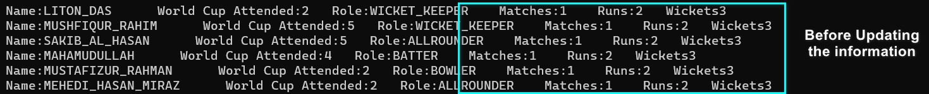

Screenshot 1

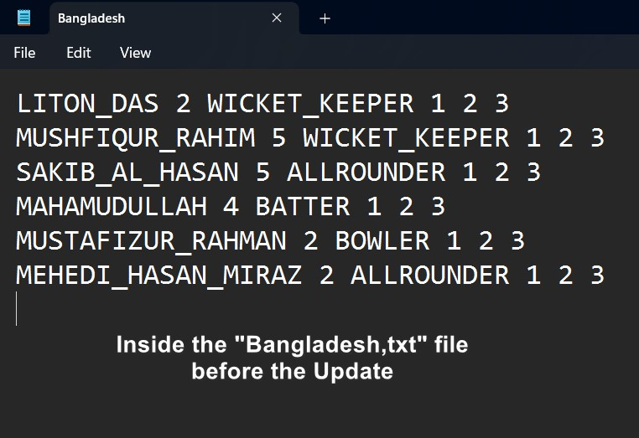

Screenshot 2

* First, we need to choose option 3 to get to the update part of the project.

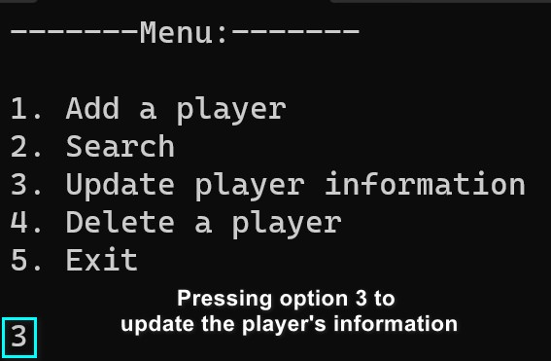

Screenshot 3

* Before updating the information of a player, the user will have to choose the team of the targeted player. The user can select a team by entering a number from 1 to 10 where files of 10 teams are connected. If the user enters an invalid input then an “Invalid Option” message will be displayed. The user will have the option to re-enter the valid option or the user can go back to the menu.

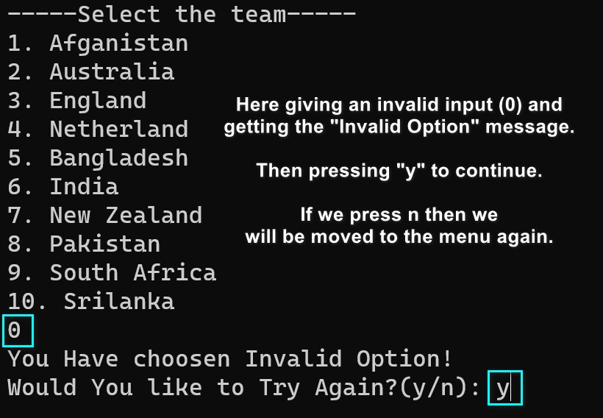

Screenshot 4

* Then as we are updating the Bangladeshi player’s information we are choosing option 5.

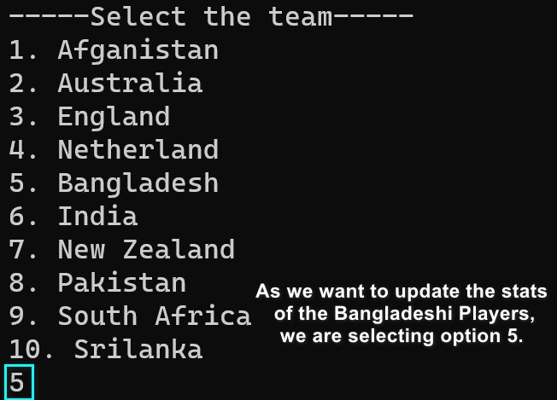

Screenshot 5

* Then we have to enter the name of the targeted player, in this case it’s Shakib Al Hasan. After entering the name the user has to input the updated values of matches, runs and wickets. Then a line will appear which will display the “updated successfully” message. Below the message, another line shows whether the user wants to update any other player or not. If yes then it will take the user to select the team part otherwise the user will choose n and move to the menu.

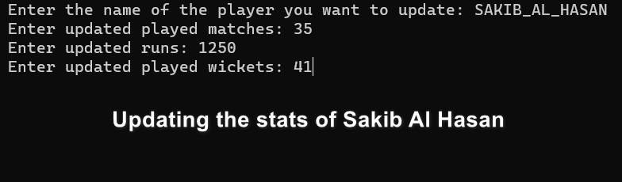

Screenshot 6

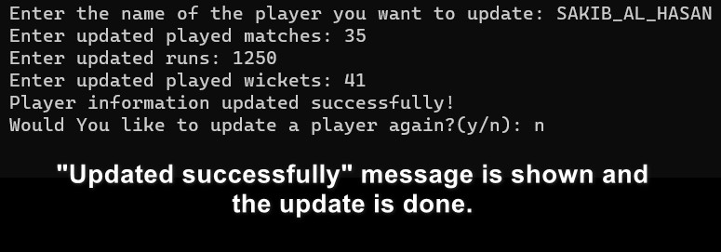

Screenshot 7

* So the stats of Shakib Al Hasan have been updated and with the help of the search function (Information of a player), we can see the updated stats of Shakib Al Hasan. The update can be noticed inside the “Bangladesh.txt” file as well.



Screenshot 8

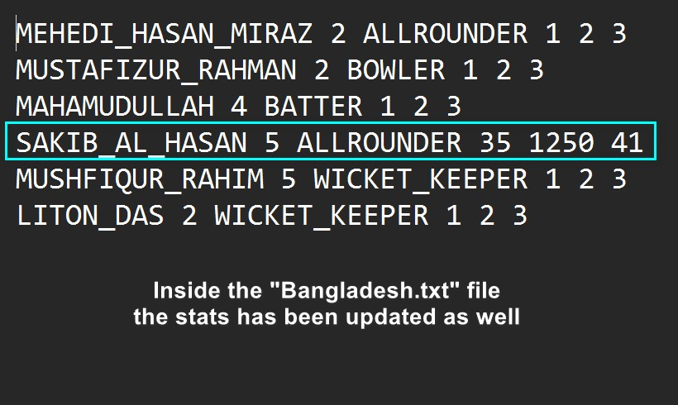

Screenshot 9

* In this way, we can update the information or stats of all the players in this

World Cup.

Here is the Updated player’s list of these players.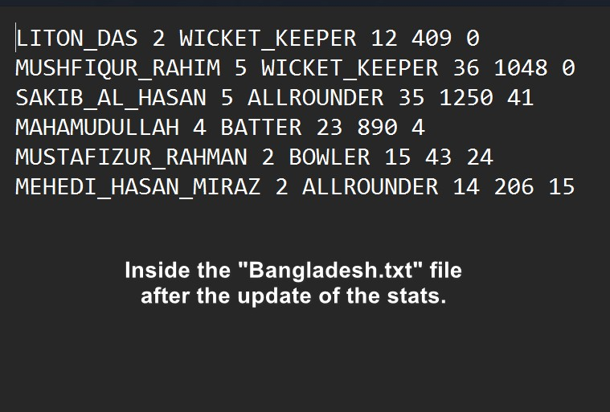

Screenshot 10

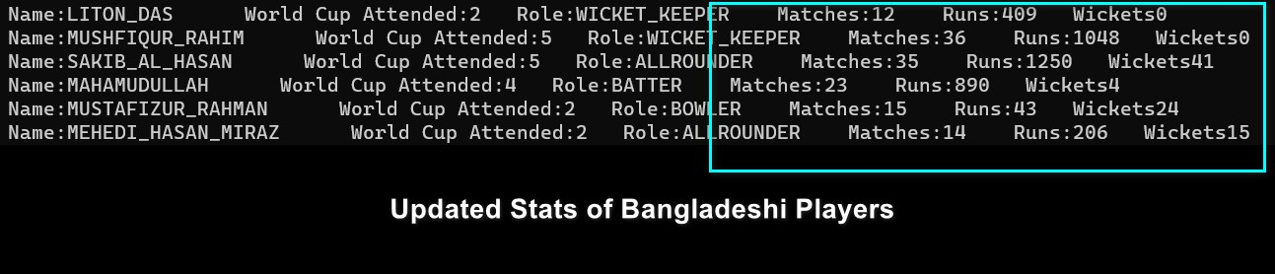

Screenshot 11

So, as the screenshots suggest, this function is updating the information or stats of the players and saves the changes to the file as well.

**5. Display():**

This function opens a sub-menu to show listing of all players in different ways.  
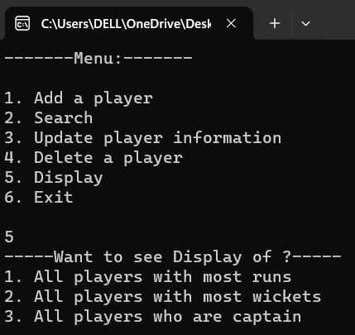  
  
Listing1 will display all players in descending order of their runs. Hence easier to spot the batter who scored the highest run in the whole tournament.  
  
Listing2 will display all players in descending order of their runs. Hence easier to the bowler who took the highest wickets in the whole tournament.  
  
Listing3 will display all the captains from all the teams that participated in the tournament.

**Applications and Use of The Project:**

1. This can be used for storing player information as a database.

2. This can be used to analyze a player's performance.

3. This can be used to compare players’ stats

**Limitations:**

1. This project lacks information about a player’s playing style. The age of a player, his batting hand, bowling type and much other information are absent in this project.

2. This project lacks the in-depth statistics of a player. Here we have just included the number of World Cup attended, the number of matches, and the amount of runs and wickets. But other stats like batting and bowling averages, strike rate, economy, number of 100s, 50s (for Batters), 4-fer’s,5-fer’s(for Bowlers) and catches and stumps (for wicket Keeper) are missing.

3. This project can’t verify whether the given name is of a current World Cup player or not.

4. When it updates the stats or information it removes the previously stored information, so in this database we can’t trace the changes.

5. When we update the stats we have to do all these manually and there are no options for arithmetic operations, the user only can give input.

6. Redundancy, especially vehicle choosing teams can be found in this code.

**Future Work:**

1. More player-centric information can be added

2. More stats can be added

3. A feature to verify the authentic cricket player can be added

4. The update function can store permanent values where new values will be added to the existing values.

5. Make this code more efficient and compact

**Source of the stats or information**

All the data or stats are collected from Espncricinfo’s “player’s profile” and “World Cup stats” sections

**Backup link**

**In this link all project-related documents and files are stored as a backup**

[**ICC Men's ODI World Cup 2023 Players Database**](https://drive.google.com/drive/folders/1yCBfbWbMSQ4C3HM_pMzxI6yuPh88YmeF)

**—-The End—--**